Parent Instructions to navigate Google Drive
1. Go to www.google.com
2. In the top right corner, you will see a blue button that says “sign in.” Click that button. (If you are already signed in to a personal account, you will have to sign out of yours first).
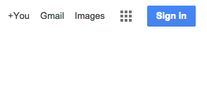

3. Each student has been provided with a username and a password. You will have to enter it to sign in.
-Student usernames are formatted like this: example@student.d124.org
-Student passwords are a series of numbers: #####

4. Once you enter the username and password, you may be directed to another screen to login through Evergreen Park School District 124. For the username, you only need to enter the portion before @student.d124.org, but if you enter the entire thing, it should work as well.
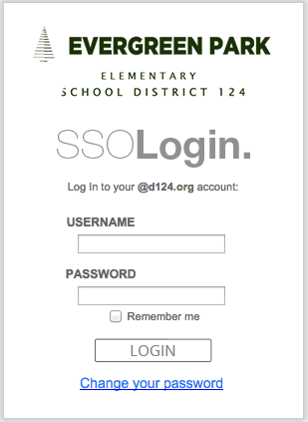

5. Once your login is successful, you should look for a square icon in the top right portion of the screen. It looks like a waffle.
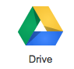
6. By clicking on that, you can access all aspects of the student’s Google Drive.

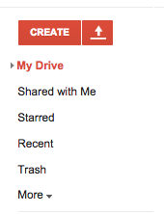
By clicking on the “Drive” icon, it will allow you to see any work that the student has created on their Google Drive. On the left hand side of the Drive you can navigate through the student’s files.

“My Drive” may have folders for different assignments that the student has created. If you click on the arrow to the left of “My Drive,” you will see any folders that appear (if they have been created). To the right, all of the documents will be shown.

By clicking on “Shared with Me,” you will be able to see any documents that have been shared with the student from their teacher or another student if it is group work.

The “Create” button allows the student to create a variety of things; documents, presentations, spreadsheets, etc.

If the student needs to upload anything onto their Google Drive, the upward pointing arrow directly to the right of the “Create” button allows them to upload any files (or entire folders) into their Google Drive.
To go into your child’s email account, you can find the waffle again in the top right of the screen.
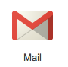
Click it and look for the “Mail” icon. In the email account you can navigate through any emails that the student has received or any emails that they have sent. Student accounts are set up so that they can receive or send emails to any District 124 staff members. They are not allowed to send emails to other students.

If you have any other questions, please contact the district Digital Learning Coach, Paul Kaskovich, at pkaskovich@d124.org

